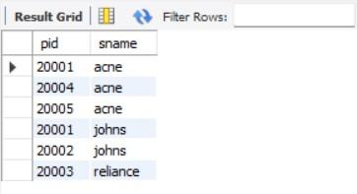

## **NoSQL Lab 1**

### **Question (Week 8)**

Perform the following DB operations using MongoDB.

1. Create a database “Student” with the following attributes Rollno, Age, ContactNo, Email-Id.
2. Insert appropriate values
3. Write a query to update the Email-Id of a student with rollno 10.
4. Replace the student name from “ABC” to “FEM” of rollno 11.
5. Export the created table into local file system
6. Drop the table
7. Import a given csv dataset from local file system into mongodb collection.

**Create database db.createCollection**(**"**Student**"**)*;* Show dbs;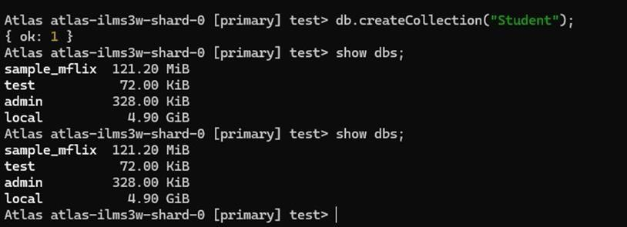

### **Create table & Inserting Values to the table**

db.Student.insert({RollNo:1,Age:21,Cont:9876,email:"[antara.de9@gmail.com](mailto:antara.de9@gmail.com)"});

db.Student.insert({RollNo:2,Age:22,Cont:9976,email:"[anushka.de9@gmail.com](mailto:anushka.de9@gmail.com)"});

db.Student.insert({RollNo:3,Age:21,Cont:5576,email:"[anubhav.de9@gmail.com](mailto:anubhav.de9@gmail.com)"});

db.Student.insert({RollNo:4,Age:20,Cont:4476,email:"[pani.de9@gmail.com](mailto:pani.de9@gmail.com)"});

db.Student.insert({RollNo:10,Age:23,Cont:2276,email:"[rekha.de9@gmail.com](mailto:rekha.de9@gmail.com)"});

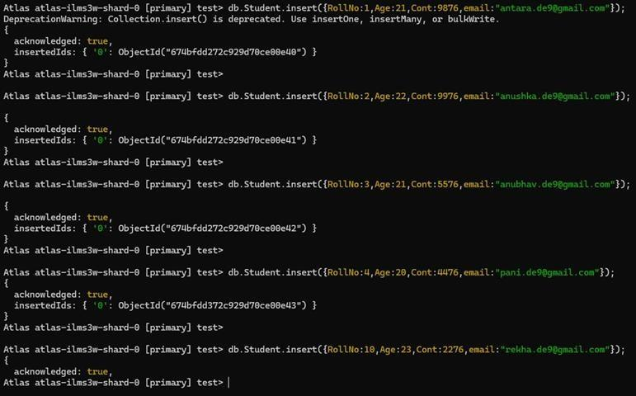

### **Structure of the table**

db.Student.**find()**;

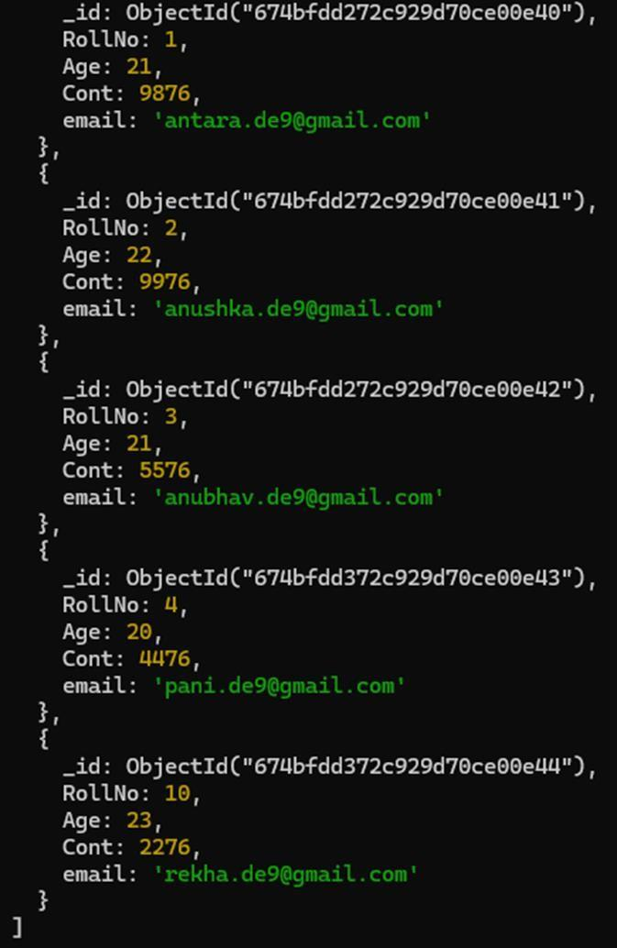

### **Queries**

* **Write a query to update the Email-Id of a student with rollno 5.**

db.Student.update({rollno:5},{$set:{em[ail:"abhinav@gmail.com](mailto:abhinav@gmail.com)"}});

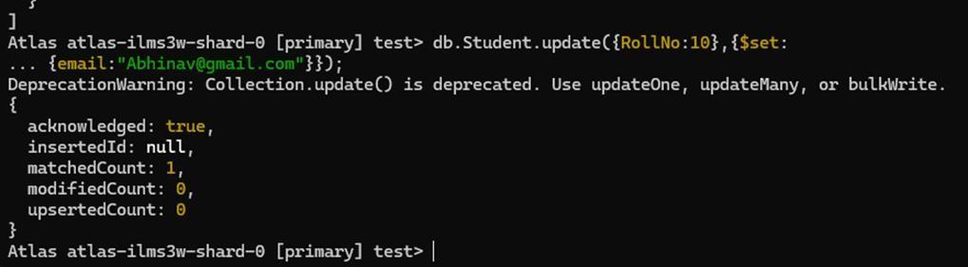

### **Replace the student name from “ABC” to “FEM” of rollno 11.**

db.Student.update({RollNo:11,Name:"ABC"},{$set:{Name:"FEM"}})

